**Write Dockerfiles** for the game to define the environment and dependencies needed to run the game.

**Dockerfile:**

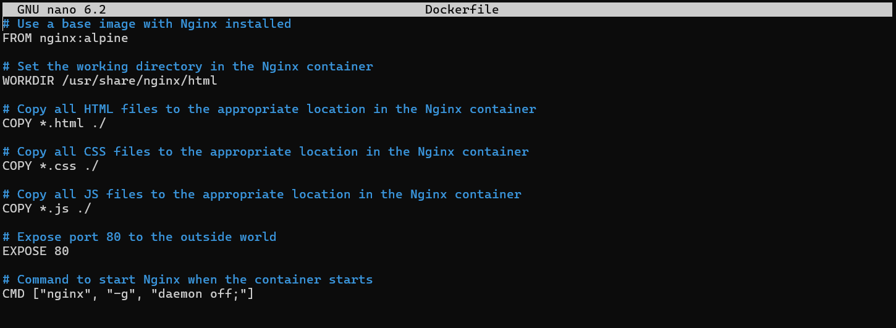

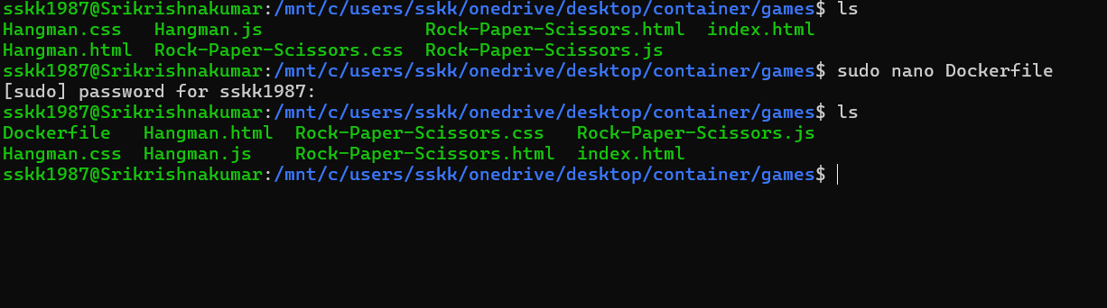

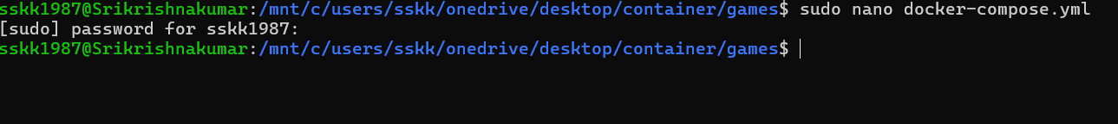

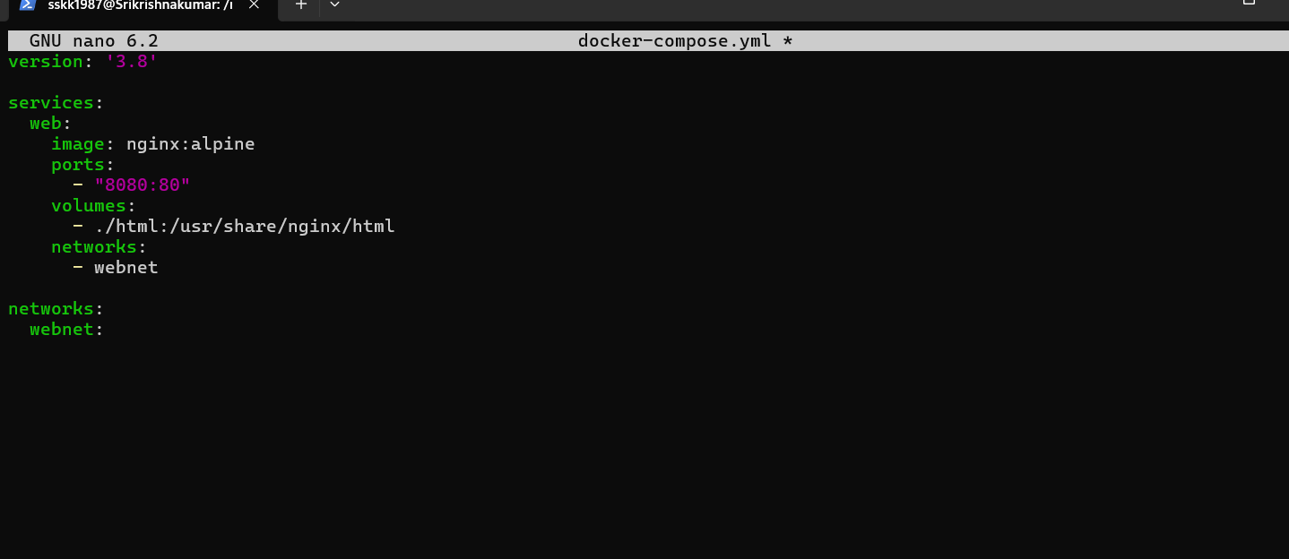

**2. Build the Docker Image:**

Open a terminal and navigate to your project directory containing the Dockerfile.

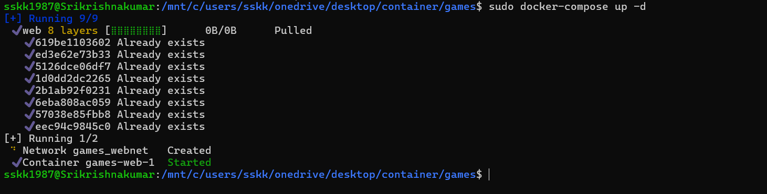

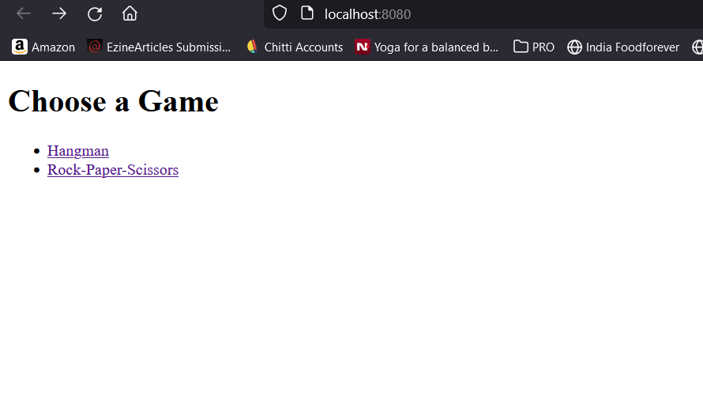

Run the following command to build the Docker image:

bash

docker build -t my-web-app .

Replace my-web-app with the desired name for your Docker image.

### 3. Push the Docker Image to Amazon ECR:

Ensure you have the AWS CLI installed and configured with appropriate credentials.

Tag your Docker image with the ECR repository URI. You can find the URI in the ECR console.

bash

docker tag my-web-app:latest <ECR repository URI>/my-web-app:latest

Login to ECR using the AWS CLI.

bash

aws ecr get-login-password --region <region> | docker login --username AWS --password-stdin <account_id>.dkr.ecr.<region>.amazonaws.com

Replace <region> and <account_id> with your AWS region and account ID respectively.

Push the Docker image to ECR.

bash

docker push <ECR repository URI>/my-web-app:latest

• **Create an Amazon EKS Cluster:**

* Log in to the AWS Management Console.
* Navigate to the Amazon EKS service.
* Click on "Create cluster" and follow the wizard to configure your EKS cluster.
* Choose a name for your cluster and select the Kubernetes version.
* Configure networking options, such as VPC and subnets.
* Choose an IAM role that grants necessary permissions to the EKS service to manage resources on your behalf.
* Select the desired instance types and the number of nodes for your worker nodes.
* Review the configuration and click on "Create" to create your EKS cluster.

**Configure kubectl Authentication:**

* Install and configure the AWS CLI on your local machine if you haven't already.
* Run the aws eks update-kubeconfig command to create or update your kubeconfig file with the authentication details for your EKS cluster.

**Verify Cluster Creation:**

* Run kubectl get svc to verify that kubectl is configured correctly and can communicate with your EKS cluster.